Math 12
Benchmark Problems
Spring 2005

Committee Members: Dan Balaguy (submitted problems), Vicki Day (in spirit since we met at times that conflicted with Vicki), Donna Latham, Cliff Myers, Sabrina Newsome, Laurie Pieracci.

- Basic Concepts
  - Exponents and Radicals
    - Simplify: 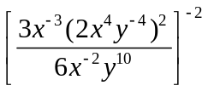
    - Simplify: 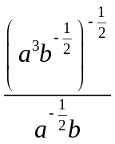
    - Simplify: 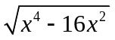
    - Rationalize the denominator: 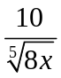
    - Rationalize the numerator: 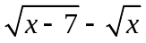

  - Polynomials, Factoring, Special Products
    - Factor: 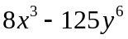
    - Factor: 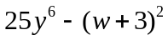
    - Factor: 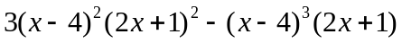
    - Factor: 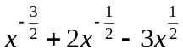
    - Factor: 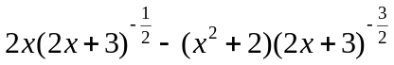
    - Multiply: 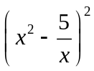

  - Fractional Expressions
    - Simplify: 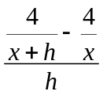
    - Simplify: 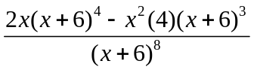

  - Linear and Quadratic Equations
    - Solve for x: 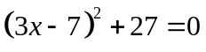
    - Solve for x: 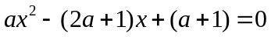
    - Solve for x: 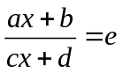
    - Solve: 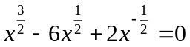
    - Solve: 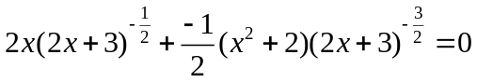
    - Solve: 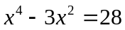
    - Solve: 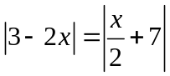

  - Linear, Non-Linear and Absolute Value Inequalities
    - Solve: 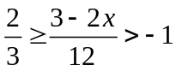
    - Solve: 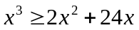
    - Solve: 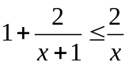
    - Solve: 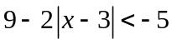
    - Express in interval notation: 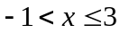 and 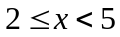

  - Problem Solving/Word Problems
    - The town of Foxton lies 10 miles north of an abandoned east-west road that runs through Grimely, as shown in the figure below. County officials are about to build a new road connecting the two towns. They have determined that restoring the old road would cost $100,000 per mile, while building a new road could cost $200,000 per mile. How much of the abandoned road should be used (as indicated in the figure) if the officials intend to spend exactly $86.8 million? Would it cost less than this amount to build a new road connecting the towns directly?
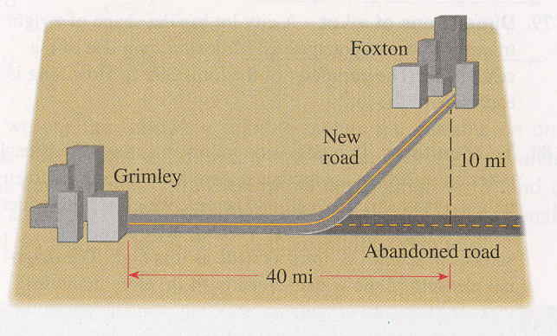
    - Using calculus it can be shown that if a ball is thrown upward with an initial velocity of 16ft/sec from the top of a building 128 ft high, then its height h above the ground t seconds later will be 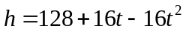. During what time interval will the ball be at least 32 ft above the ground?
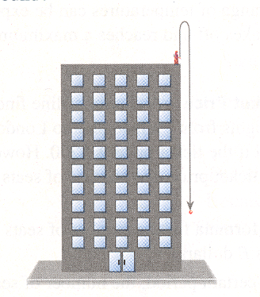
    - A gardening enthusiast wishes to fence in three adjoining garden plots, one for each of her children, as shown in the figure. If each plot is to be 80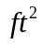 in area, and she has 88 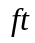of fencing material at hand, what dimensions should each plot have?
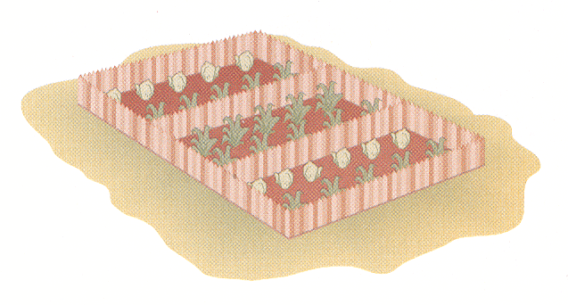
  - Complex Numbers
    - Simplify: 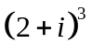
    - Simplify: 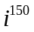
    - Solve: 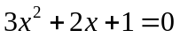
    - Factor 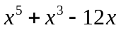 over the complex numbers.

- Functions and Graphs
  - Definition of Function and Evaluation of functions
    - Find 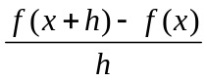 if
      - 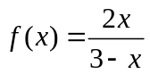
      - 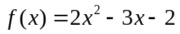
    - Find the domain of
      - 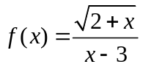
      - 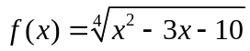
  - Graphing of Functions
    - Zeros, or Roots, and Intercepts of Function
      - Determine all zeros and graph:
        - 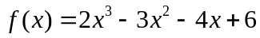
        - 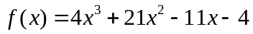 using the Rational Root Theorem
      - Write a polynomial function with real coefficients of degree 4 with zeros, 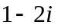, 3 (with multiplicity two) such that 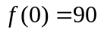

    - Asymptotes of Functions
Find all of the asymptotes for the graphs of f:
        - 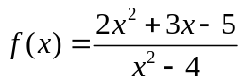
        - 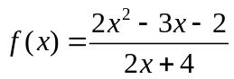
        - 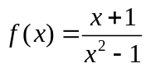

    - Shifting and Reflection of Functions
      - Given the following graph of ,
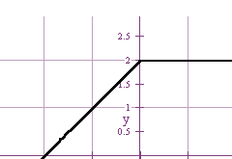
-2 -1 0 1 2

sketch the graph of
        - 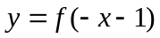
        - 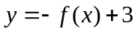
        - 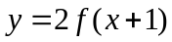
      - Sketch the graph of each and show steps:
        - 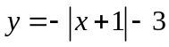
        - 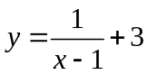
        - 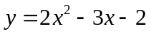
    - Symmetry
Determine whether 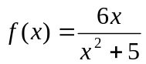 is odd, even, or neither.

  - Combination and Composition of Functions
    - If 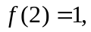 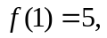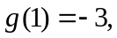find:
      - 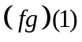
      - 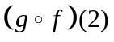
    - If and 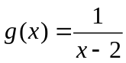, find 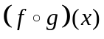 and state the domain.

  - Inverse Functions
    - If , find each of the following:
      - 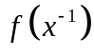
      - 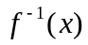
      - 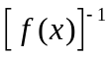

  - Conic Sections
    - Rewrite the following conics in standard form, sketch the graph showing all intercepts, foci, vertices and asymptotes (if they exist).
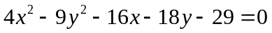
2) Write the equation of a parabola with directrix 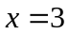and focus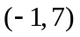.

- Logarithms, Exponentials and Logarithms
  - Review of Exponents and Logarithms
    - Simplify: 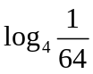
    - Convert to exponential form: 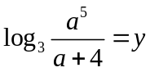
    - Use properties of logarithms to expand: 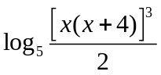

  - Solving Equations with Exponentials and Logarithms
    - Solve for t: 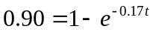
    - Solve for x: 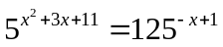
    - Solve for m: 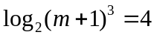
    - Solve for x: 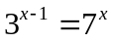
    - Solve for x: 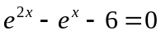
    - Solve for x: 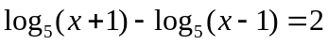
    - Solve for x: 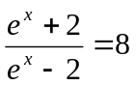
    - Solve for x: 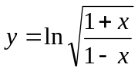

  - Graphing Exponential and Logarithmic Functions
    - Graph: 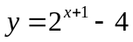
    - Graph: 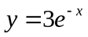
    - Graph: 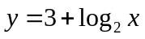

  - Word Problems with Logarithmic and Exponential Equations
    - A recent study shows that about 35% of all aluminum cans are recycled each year. If a shipment of 100,000 cans is released in the market, after how many years will there by only 46,000 or fewer cans. Round your answer to the nearest a whole number.
    - A laptop computer is purchased for $2100. If its value each year is 65% of its value in the previous year, how much will the laptop computer be worth after 3 years? Round your answer to the nearest dollar.
    - A culture starts with 8600 bacteria. After one hour the count is 10,000.
      - Find the number of bacteria after 6 hours.
      - After how many hours will the number of bacteria double?

- Systems of Equations and Matrices
  - Solving Systems of Equations
    - Substitution : 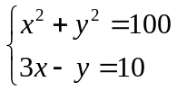
    - Elimination: 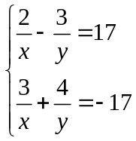

  - Introduction to Matrices
    - Algebra of Matrices
If 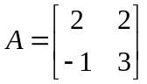, 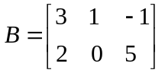, 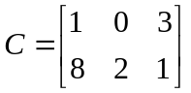, find each of the following, if possible:
        - 
        - 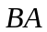
        - 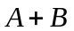
        - 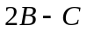

    - Elementary Row Operations
Rewrite the following augmented matrix in reduced row –echelon form: 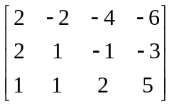

    - Inverse of a Square Matrix
Find 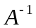, if
        - 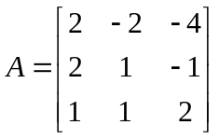

  - Matrices as a Method of Solving a System of Equations
Solve the system: 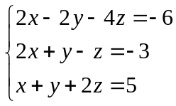using
    - Gauss-Jordan Elimination (Elementary Row Operations)
    - Inverse Matrices as time permits
    - Cramer’s Rule

- Binomial Expansion and Combinatorics
  - Expand Binomial
    - Pascal’s Triangle
Use Pascal’s Triangle to write the first 3 terms in the expansion of 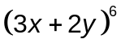

    - Combinations
Use the binomial theorem to find the coefficient of 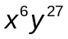 in the expansion of 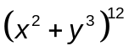

3) Evaluate 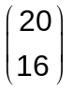

  - Combinatorics (as time permits)
    - Combinations
In how many ways can a committee of 4 professors be formed from a department containing 15 professors?

    - Permutations
Six different math books are to be arranged on a student’s desk. How many different arrangements are possible?

    - Counting Techniques
An urn contains 7 white balls and 3 red balls. Three balls are selected. In how many ways can the 3 balls be drawn from the total of 10 balls
a) if 2 balls are white and 1 is red?
- if all three balls are white?
- If all three balls are red?

- Sequences and Mathematical Induction
  - Arithmetic Sequences
    - Find the 60th term in the sequence: 2, 5, 8, 11, …

    - Find the sum: 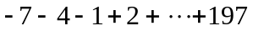

    - Find the sum: 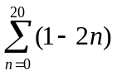

    - An amphitheater has 50 rows of seats with 30 seats in the first row, 32 in the second row, 34 in the third and so on. Find the total number of seats.

  - Geometric Sequences
    - Find the 10th term in the sequence: 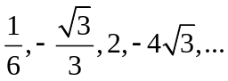
    - Find the sum: 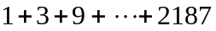
    - Find the sum: 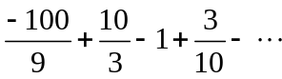
    - A ball is dropped from a height of 9 feet. The ball always bounces up the distance it has fallen. Find the total distance the ball has traveled at the instant it hits the ground the 5th time.

  - Introduction to Mathematical Induction
    - Prove: 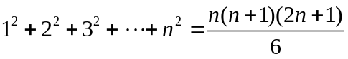

    - Prove: 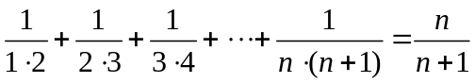

    - Show that: 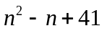 is odd for all natural numbers n.

