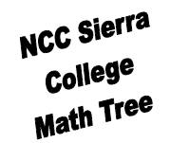

**Beginning Algebra (online)**

**Math A (4)**

*Students may start anywhere along the tree based on assessment or matriculation results.

*Arrows indicate possible course paths (not prerequisites)  
*Units are listed in ( )

**Diff Eq/Linear Alg**

**Math 33 (6)**

**Foundations of Math**

**Math 585 (6)**

**Problem Solving**

**Math 10 (4)**

**Statistics**

**Math 13 (4)**

**The Nature of Mathematics**

**Math 18 (3)**

**Calculus III**

**Math 32 (4)**

**Calculus II**

**Math 31 (4)**

**Calculus I**

**Math 30 (4)**

**Trigonometry**

**Math 27 (4)**

**College Algebra Math 12 (4)**

**Intermediate Algebra**

**Math D (5)**

**Practical Mathematics Math E (6)**